**Name: Katie Lee**

**Name of partner(s) if you worked with someone on this assignment: Elodia Lunn**

**Hands On 7 Questions**

**Problem 1: Notetaking factorial experiment**

1. **What were the mean memory test scores in the writing and typing conditions?**

**Write = 8.92**

**Type = 6.36**

1. **Was there a significant main effect of notetaking format on memory test scores?** Assume that a difference of more than 1 point is statistically significant *(in reality, we would use ANOVA or regression to test for significance, but those are the domain of a stats class!)*. In a sentence, interpret this main effect (or lack thereof) of notetaking format.

*(“Interpret” means explain the nature of the effect in everyday language. For example, an interpretation of the main effect of social media use might be “Participants who used social media for one hour per day had lower self-esteem than participants who used social media for 5 minutes per day.” For more examples of interpretations, see the sentences in italics in the “Effects Observed” column of the answer key for the practice main effects and interactions worksheet.)*

**There exists a main effect between writing and typing. This means in more standard terms people retain more information when writing on paper than typing.**

**Since we saw that the difference between 8.92 and 6.36 is greater than 1 thus this is statistically significant.**

1. **What were the mean memory test scores of Gen Z and Boomer participants?**

**Gen Z = 7.827586**

**Boomer = 7.236364**

1. **Was there a significant main effect of generation on memory test scores?** Assume that a difference of more than 1 point is statistically significant. In a sentence, interpret this main effect (or lack thereof) of generation.

**There was not a significant main effect of generation on memory test scores. Or more so it did not matter whether you were a boomer and gen z, their memory retention was not different.**

**Since the difference between 7.827586 and 7.236364 is not greater than 1 this result is not statistically significant**

1. **Fill in the below table with the four mean memory scores you calculated.**

|  | **Write** | **Type** |
| --- | --- | --- |
| **Gen Z** | 8.1111 | 7.58065 |
| **Boomer** | 9.8 | 5.1 |

1. **Was there a significant notetaking format x generation interaction on memory test scores?** Assume that a difference of more than 1 point is statistically significant. In 1-3 sentences, interpret this interaction, or lack thereof.

**The interaction effect is significant because the difference in effects of notetaking styles (writing vs. typing) across generations (Gen Z and Boomers) exceeds 1 point, with differences calculated as -0.53046595 and -4.7 respectively.**

1. **State whether each independent variable is a true IV or a pseudo IV. How does this affect our interpretation of the results?**

**true ID = writing or typing**

**pseudo ID = Gen Z or Boomer**

**This effects our interpretation because of issues in generalizability, with pseudo IV as researchers we have more control over the experiment and can isolate the variables whereas when we have a pseudo IV there can be more confounding variables that could effect the experiment (thus lower internal validity)**

1. **Is this experiment a between-subjects design, within-subjects design, or mixed design?** If the experiment is a mixed design, indicate which independent variable is between-subjects and which is within-subjects.

**It is a mixed design**

**Within = notetaking styles**

**Between = generation**

**Problem 2: Democratic values factorial experiment**

In their paper, “Misperceptions about out-partisans’ democratic values may erode democracy,” Dr. Pasek and colleagues (2022) examined how much Democrats and Republicans think their own versus opposing political party members value core democratic norms, such as free and fair elections and equal rights for all adult citizens. In Study 2, the authors recruited a nationally representative sample of 977 Americans (488 Democrats and 489 Republicans). They asked each participant to rate how important the average Democrat and the average Republican thought core democratic norms were on a scale from 0 (not at all important) to 100 (extremely important) in a random order. The results are shown in the graph below.

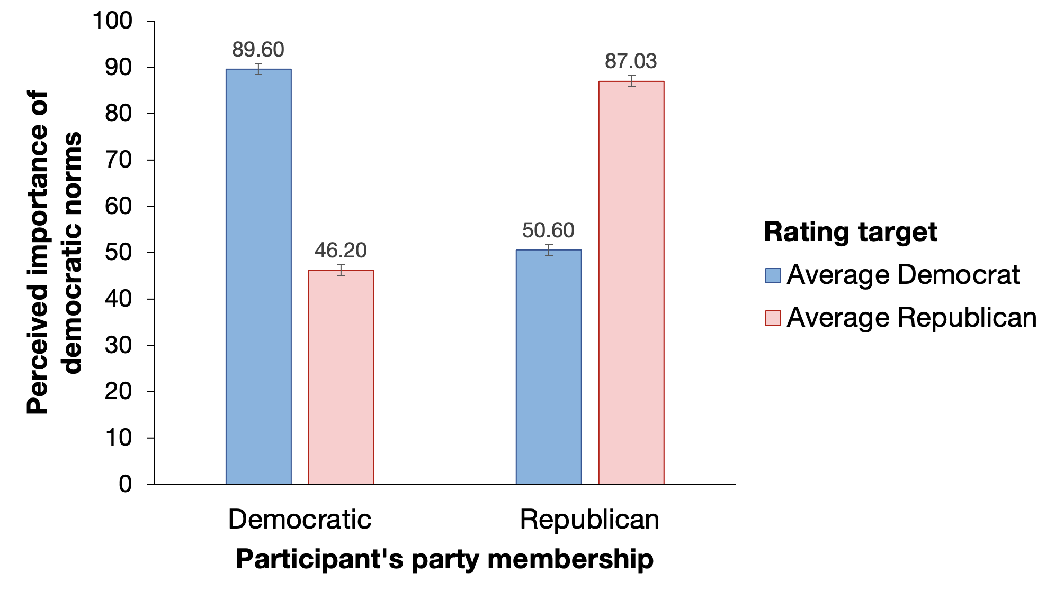



1. **Fill in the blanks**: This experiment uses a 2 x 2 factorial design.
2. **Is this experiment a between-subjects design, within-subjects design, or mixed design?** If the experiment is a mixed design, indicate which independent variable is between-subjects and which is within-subjects.

**This is a between subjects because you cant assign/change their membership from being a democrat to a republican.**

1. **Based on the graph, was there a significant main effect of participant party membership (Democratic vs. Republican) on perceived importance of democratic norms?** Assume that a difference of 5 points is statistically significant. In a sentence, interpret this main effect (or lack thereof) of participant party membership.

There is not a significant main effect of a participant's party membership on perceived importance of democratic norms, as the difference between the two groups (68.8 and 66.4) is around 2, which is less than 5.

1. **Based on the graph, was there a significant main effect of rating target (the average Democrat vs. the average Republican) on perceived importance of democratic norms?** Assume that a difference of 5 points is statistically significant. In a sentence, interpret this main effect (or lack thereof) of rating target.

There is not a significant main effect of rating target on perceived importance of democratic norms. Since the difference is less than 5 points, it is not considered significant because it did not reach the threshold. 66.615 or 70.1

1. **Based on the graph, was there a significant participant party membership x rating target interaction on perceived importance of democratic norms?** Assume that a difference of 5 points is statistically significant. In 1-3 sentences, interpret this interaction (or lack thereof).

There exists an interaction between the participant’s party membership and the rating target on perceived importance of democratic norms. The differences observed between their own and the opposing party's perceived importance are significantly greater than 5.

**Problem 3: Your own factorial experiment**

Propose a 2 x 2 factorial experiment using two independent variables and one dependent variable of your choice. Make sure that at least one of the independent variables is a true IV (so that it is an experiment) – the other can be a true or pseudo IV.

1. **Fill out the following table with your two independent variables, levels of your independent variables, and dependent variable. Be sure that your variables are fully operationalized.** See the instructions document for an example.

**Then, in the four cells, make a prediction for how people in each of the four cells will score on your dependent variable on average.** You can completely make up the numbers, but think about the relative relationship you would predict between the cells. Make sure that your numbers align with any hypothesized main effects and/or interactions, or lack thereof.

| **DV: *Stress levels (1-7)*** | | **IV 1: *Amount of Work Hours*** | |
| --- | --- | --- | --- |
| ***Less than 30 hours a week*** | ***More than 30 Hours a week*** |
| **IV 2: *Location of Work*** | ***Remote*** | *3* | *5* |
| ***In Person*** | *4.5* | *7* |

1. **Are you predicting a main effect of IV 1? Explain your reasoning for why you would or would not expect a main effect of IV 1.**

We are expecting a main effect of IV 1 we believe that working more hours will increase your stress levels significantly

1. **Are you predicting a main effect of IV 2? Explain your reasoning for why you would or would not expect a main effect of IV 1.**

Yes because remote is a more comfortable space than going to work. This allows you to wake up later and also its a less stressful environment and thus we believe there will be a main effect of IV 2

1. **Are you predicting an interaction between IV 1 and IV 2? Explain your reasoning for why you would or would not expect an IV 1 x IV 2 interaction.**

We would be expecting an interaction between IV1 and IV2. We predict working more than 30 hours is more stressful for in-person workers due to commuting and being in a potentially high-stress environment. In contrast, remote workers might not experience as much stress from longer hours due to the comfort and flexibility of working from home. WHen working less than 30 hours, there might not show as pronounced a difference between remote and in-person work regarding stress levels, leading to the prediction of an interaction between the two independent variables.